FIRST
Create new Admin account

Powershell elevated
sconfig, 6 for all, install security updates

Turned on all Windows Defender Settings

AD Users and Computers
Reset Kerberos password (password 1 YyHhKLL76

Disable Richard G. Johnson Account (Password 7Ytbu88Ku

Disable Administrator (Password BG8K**LPi

Disable Admin Admin builtin (Password CFy776RRui

Add Richard G. Johnson, Administrator, and Admin admin to Protected Users
Remove Administrator from Schema Admin

Remove Authenticated Users from the Pre-2000 Windows Compatible Access Group

GPO
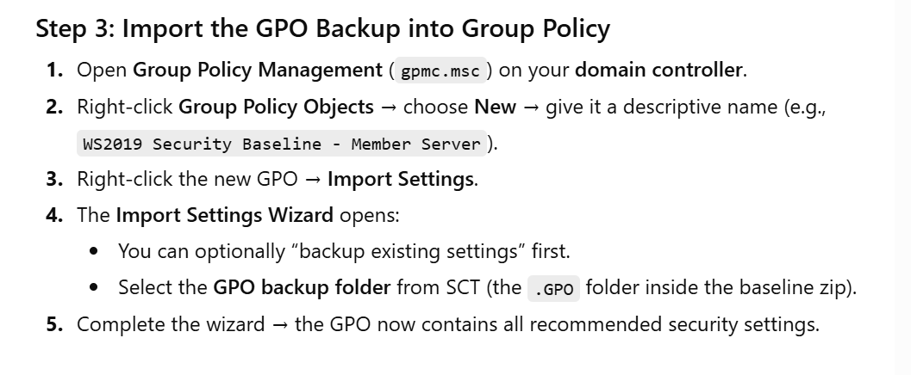
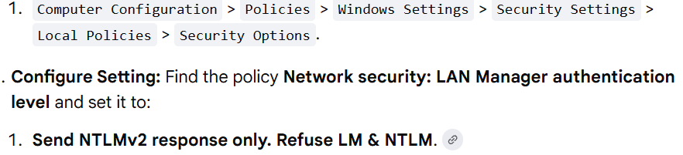
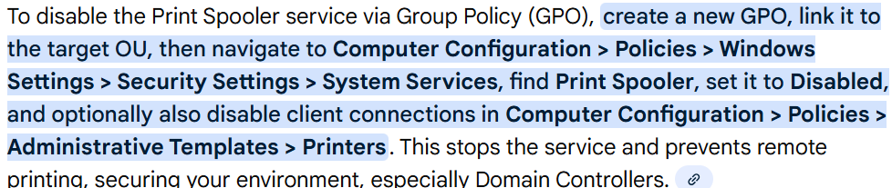

Elevated Powershell

reg add HKLM\SYSTEM\CurrentControlSet\Services\NTDS\Parameters /v LDAPServerIntegrity /t REG_DWORD /d 2 /f
Set-ADDomain -Identity "CCDCTeam.com" -Replace @{"ms-DS-MachineAccountQuota"="0"}


DNS
Delete all ptr records
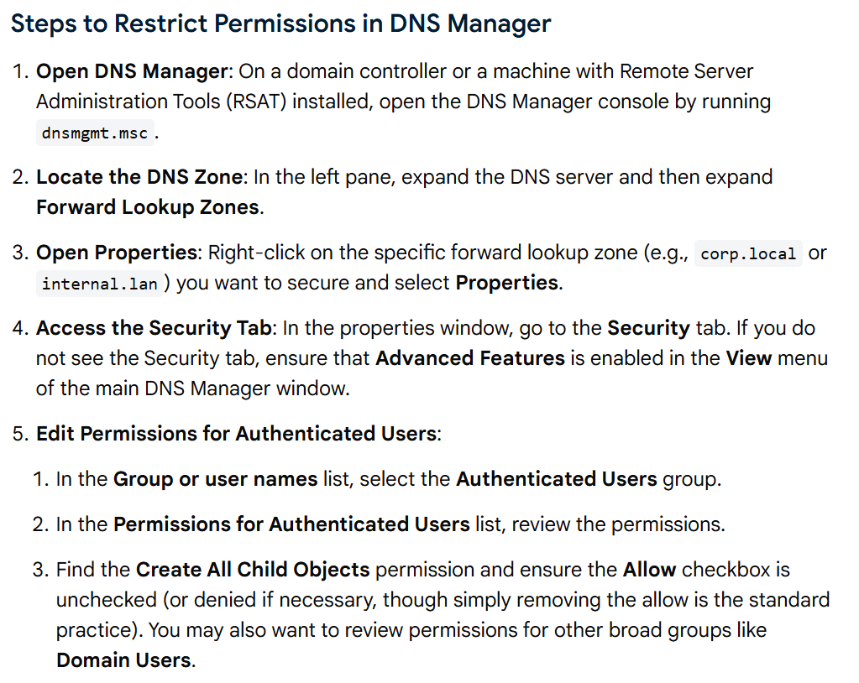

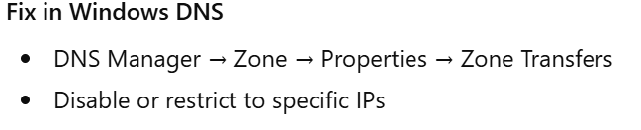

Services
Go into Services
Disable Print Spooler
Disable Remote Registry
Disable Remote Desktop

Firewall
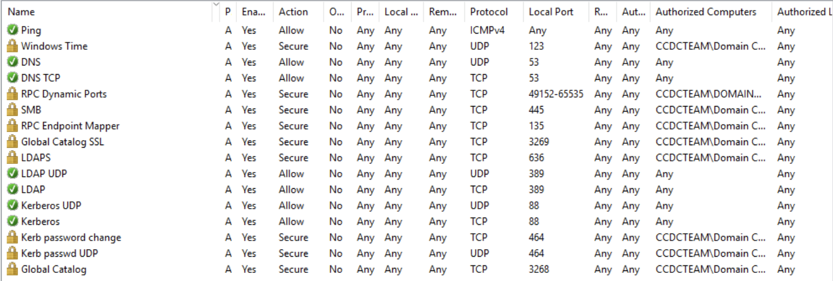

Finally
Reset all user passwords
Disable SMBv1 in elevated powershell with this command

Set-SmbServerConfiguration -EnableSMB1Protocol $false

Enforced SMB signing following these directions
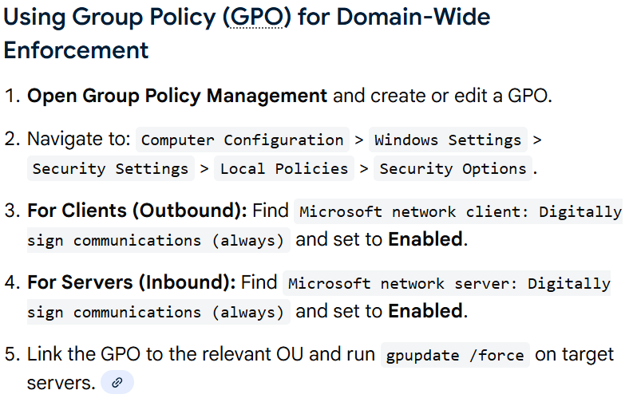
Disable LM NTLM with ese directions
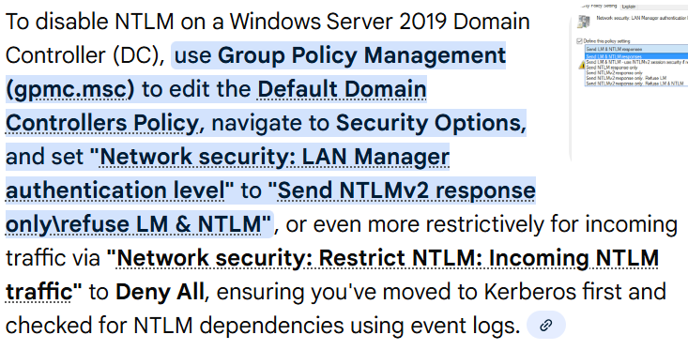
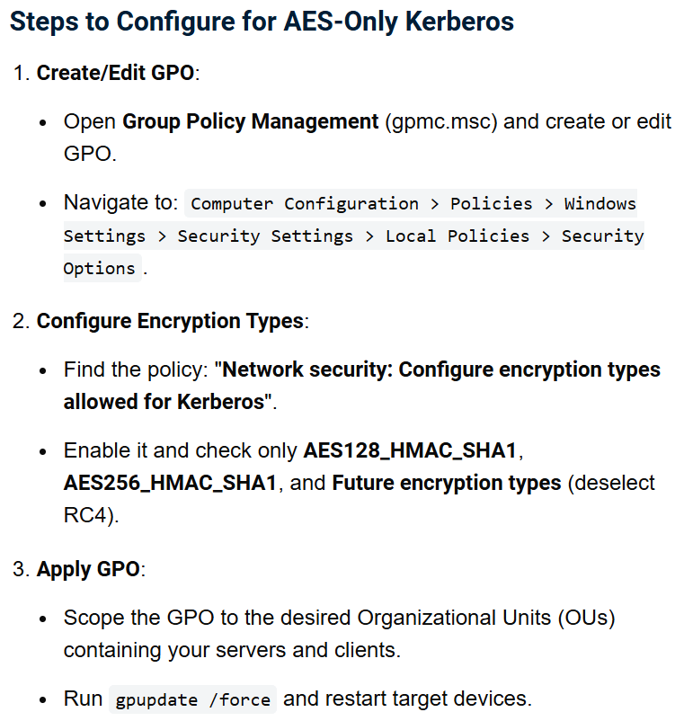
Switch tab up one to “audits” and enable auditing for logon events, account management, policy changes, and directory service access
Switch to Password and change complexity requirements
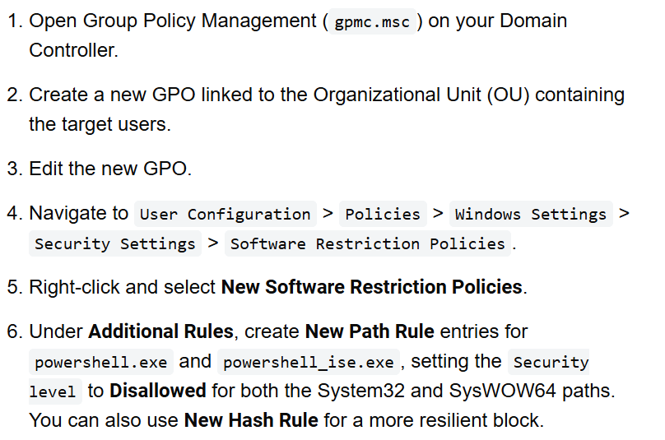
C:\Windows\System32\WindowsPowerShell\v1.0\powershell.exe
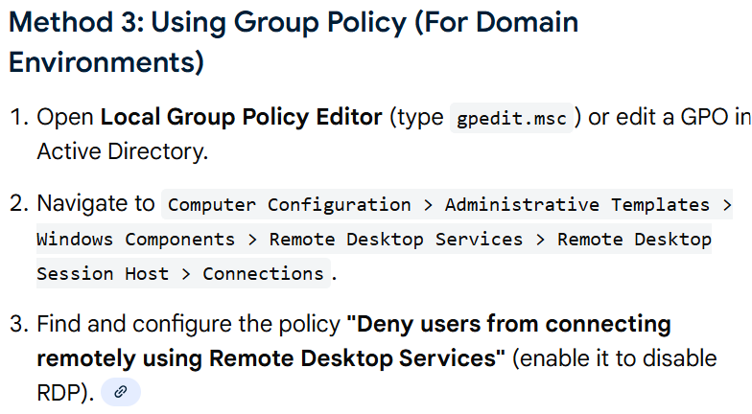

🔍 How to decide quickly (CCDC method)

Step 1: Is AD CS even installed?
Get-WindowsFeature ADCS*
If installed, look for:
- Certification Authority
- Web Enrollment

Step 2: Check if it's being used

Look for issued certs:
certutil -view
If:
- Empty or very small → likely unused

Check services depending on it:
Get-Service | findstr /i "cert nps radius"

Check event logs (quick signal):
- Event Viewer → Applications and Services Logs → Microsoft → Windows → CertificateServices
Lots of activity = maybe in use
Dead quiet = probably safe

⚡ CCDC strategy (what actually wins)

If you are unsure:
👉 Disable it temporarily and watch for breakage
Stop-Service CertSvc
Set-Service CertSvc -StartupType Disabled
Then:
- Monitor scoreboard
- Watch user complaints / service checks

Reset all user passwords

Don’t do any of this
SCT
On Server 2022 or workstation, go to this link and download the SCT https://www.microsoft.com/en-us/download/details.aspx?id=55319

Import the SCT GPO in folder 7EA149BF
Don’t do this Elevate powershell and type this

$SMB="172.20.240.254/24", “172.20.242.40", “172.16.101.254”

Set-NetFirewallProfile Domain -Enabled 1 -DefaultInboundAction Block -DefaultOutboundAction Allow

53,88 | %{
New-NetFirewallRule -D In -A Allow -P TCP -LP $_ -Pr Domain -N "DC $_ TCP"
New-NetFirewallRule -D In -A Allow -P UDP -LP $_ -Pr Domain -N "DC $_ UDP"
}

389 | %{
New-NetFirewallRule -D In -A Allow -P TCP -LP $_ -Pr Domain -N "DC LDAP TCP"
New-NetFirewallRule -D In -A Allow -P UDP -LP $_ -Pr Domain -N "DC LDAP UDP"
}

636,3268,3269 | %{
New-NetFirewallRule -D In -A Allow -P TCP -LP $_ -Pr Domain -N "DC TCP $_"
}

New-NetFirewallRule -D In -A Allow -P TCP -LP 445 -RA $SMB -Pr Domain -N "DC SMB Scoped"
New-NetFirewallRule -D In -A Block -P TCP -LP 445 -Pr Domain -N "DC SMB Block"

Set-NetFirewallProfile Domain -Enabled 1 -DefaultInboundAction Block -DefaultOutboundAction Allow

//reset dc system password in case it gets compromised by zerologon
Reset-ComputerMachinePassword -Server DC01 -Credential (Get-Credential)

